Algebra Students Actively Model Linear Functions
Friday June 27

Mike Lutz
California State University, Bakersfield

1:00 – 2:30 PM
Room: Komatke C
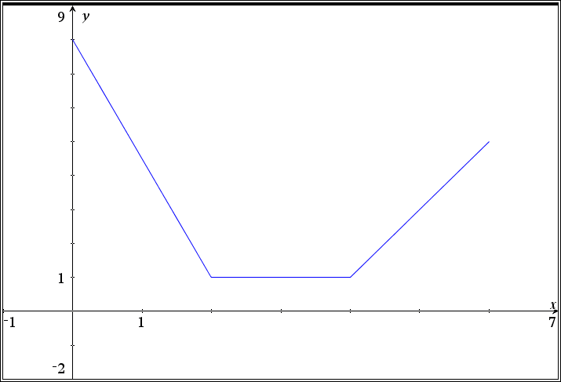
Pre-algebra and algebra students from various backgrounds have quickly gained an understanding of slope,y-intercept, and increasing/decreasing graphs by being actively engaged in collecting data on walks using CBR2s and graphing calculators. We will model the activity, discuss questions to ask students and share experiences observed during classroom use.

Name ___________________________________
Prior to each walk, predict what each scatterplot will look like
- Walker stands still 5 feet in front of the CBR

- Walker begins by walking slowly and then speeds up

- Walker begins by walking fast and then slows down
- Walker begins near the CBR and walks away at a steady rate
- Walker begins away from the CBR and walks toward the CBR at a constant rate

For each graph on the following pages do the following:
- As a whole group (class), we will write the walking instructions
- In a group of two or three with a CBR2 and an Nspire with tns file TODOS_Conference_Lutz, collect data in your group of someone walking according to the instructions created in class for each of the graphs below
- Keep trying until you have done the best that you believe you can do

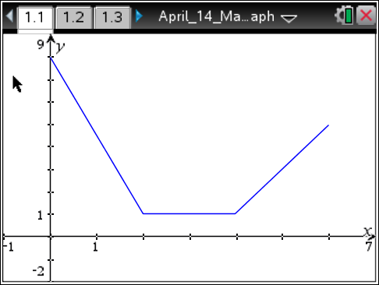

Walking instructions:

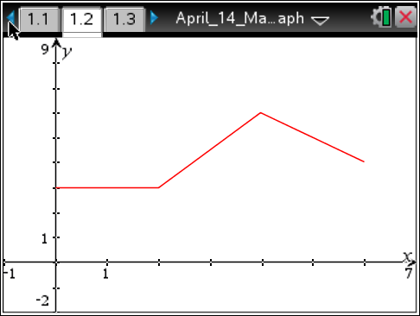

Walking instructions:

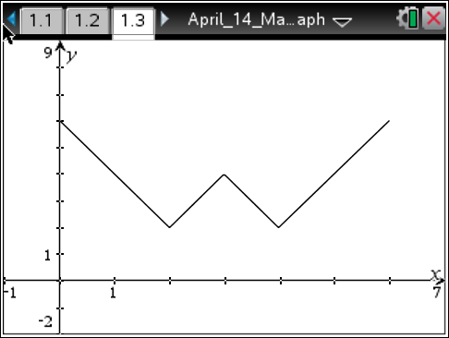

Walking instructions:

