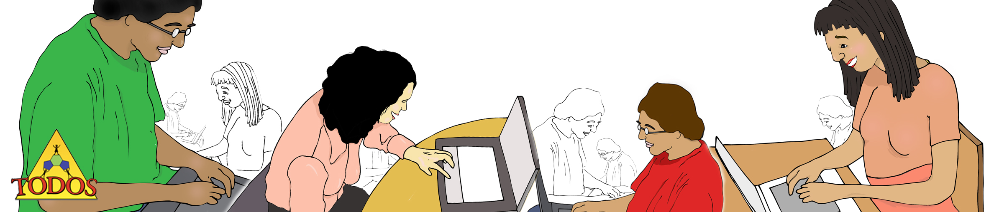

TODOS Live! Tuesday, September 29th Presented by Greisy Winicki Landman
4:00 Pm PDT; 5:00 PM MDT; 6:00 PM CDT; 7:00 PM EDT

To register for the session on September 29th, go to http://www.anymeeting.com/PIID=EC51DE88884A3F

Making Sense and Creating Connections with Transformations

One of the new content highlights of the CCSS-M is the use of transformations. During this session teachers will make sense of their definitions, their progression and the different roles they play in mathematics, not just in geometry. Teachers will be invited to reflect on the different modalities used to maintain rigorous but accessible discourse and to discuss how to implement these approaches with their own students.
~~~~~~~~~~~~~~~~~~~~~~~~~~~~~~~~~~~~~~~~~~~~~~~~~~~~~~~~~~~~~~~~~~~~~
TODOS Live! Thursday October 8th Presented by Debra Coggins
4:30 Pm PDT; 5:30 PM MDT; 6:30 PM CDT; 7:30 PM EDT

To register for the session on October 8th, go to
http://www.anymeeting.com/PIID=EC51DE88894E3A

Critique of a Lesson Plan for Inclusion of ELs

It is essential that teachers create access for all learners, including English Learners, when new concepts and procedures are taught. Collegial discussions can focus around case studies, videos of lesson examples, lesson observations, or detailed lesson plans. In this session, the focus will be on the purposeful planning of lessons that attend to concept and language development and representations. A detailed written lesson plan for teaching multiplication of a whole number by a fraction will be the context for discussion and critiquing during this session.

Recent Session available

Visual Geometry Proofs: Creating Rich Language Experiences without Language!
Presented by Shelley Kriegler with Cynthia Raff and Silvia Llamas Flores

To view the recording of this session go to http://www.anymeeting.com/PIID=EC51DF85854E38

